Dumpster Fire - Game Treatment

Game Concept 2
Genre 2
Target Audience 2
Gameplay Summary 2
Player Experience 2
Mechanics 3
Combat 3
Heat 3
Enemy spawning 3
Bosses 4
Level-ups 4
Crafting 4
Endgame 4
Art 4
Concept art- Character 5
Concept art - Enemies 5
Technical document 6

Game Concept
Dumpster Fire is a third-person, 3D survivors-like set in a bright, colorful, scrap-punk junkyard world. The player controls a scavenger/runner whose main goal is to survive with his trusted main weapon and some cobbled-together tech that auto-fires as they dodge, kite, and outsmart swarming enemies.
The key twist is Heat: as the player fights efficiently, a Heat meter rises, which overcharges their weaponry but also pushes the world into a louder, more dangerous state. When Heat reaches maximum, it triggers an Overheat Event: a massive wave culminating in a boss drop-in. Survive the event, defeat the boss, and you “cash out” a powerful reward and reset Heat to a baseline so the run keeps moving at a lively pace.

Genre
Dumpster Fire falls into what we call a Vampire Survivors-like genre, an action roguelite featuring a constantly spawning swarm of enemies that the player has to survive, upgrading his equipment and stats to match the escalating difficulty.

Target Audience
The game’s audience includes people that liked titles such as Vampire Survivors and Megabonk, people expecting a frenetic gameplay loop that lasts no more than a half hour at most. Players that enjoy competition will also be able to find enjoyment in trying to get the highest possible score.

Gameplay Summary
In our game the player must survive through endless waves of enemies to raise up the heat meter in order to defeat different bosses in the arena, collect the batteries needed to overcharge the exit and escape.
Each enemy will drop experience that the player will collect to level up and select between six buffs.

When an enemy is killed the overheat bar will start to fill, upon reaching 80% there will be an increase in enemy spawn rate and the player will shoot faster, upon reaching 100% there will be an initial wave of elites that when killed the overheat bar will drop to 0%.
When the boss spawns at the second overheat, the heat bar will stay at 100% until it is killed, after that it will reach 0% and the game will loop again.

Player Experience
In Dumpster Fire the player will be set up in a junkyard where it will have to upgrade his weapons and his physical enhancements in order to survive,this will lead to the player feeling high action moments and moments where the action slows down, but not all runs will be the same, the player will also have the option to choose between different weapons and upgrades before the run even begins to ensure a personalized experience.
We aim for a 15-20 minutes run where the player must obtain 2 power cells in order to escape the junkyard. As for this vertical slice we will design only one map but is considered in the future to be at least three.

Mechanics

Combat
Most of the core loop experience is combat. Dumpster Fire features a combat system centered around aiming and auto-aiming weapons that automatically target enemies in different ways, these weapons will have ammo which the player will be spending voluntarily when equipped and will be at an off-hand state while auto-aiming, which means the player’s main mechanical priority will be having smooth movement and avoiding the enemies that breach their kill radius. Enemies deal damage on contact with the player, with certain enemy variants having special effects on death that keep the player on his toes, always having to react to his surroundings.

The world’s design also impacts how the combat progresses. The level is divided in two “areas”: A series of interconnected floating islands in the sky, featuring unique features, enemy types and objectives, meant to give the player a slower, more controlled experience, with opportunities to engage with the weapon crafting system, and a scrapyard underneath, featuring a labyrinthic design and overflowing with enemies of all types that result in a much more chaotic combat.

Heat
Heat is the game’s signature system for controlling the rhythm and difficulty of gameplay. The player has a Heat Bar, which fills up throughout combat with every enemy killed. The higher the heat climbs, the more enemies will spawn around the player, but his own equipment will also become stronger, with weapons unlocking new effects and his movement becoming quicker. When the Heat bar gets high enough, a massive wave of enemies will come after the player, which will be forced to drop down into the scrapyard and survive long enough to reach Overheat, where a boss will spawn every now and then. Killing the boss or the elites resets the Heat bar, allowing the player to go back up to the islands, and get ready for the next loop.

Enemy spawning
Enemies spawn near the player in groups of varying size. The spawning frequency, group size and max amount of enemies change dynamically with the Heat level, but are always maintaining a stable number of enemies, meaning that they generally will respawn as quickly as you kill them, and the main change as heat increases is the number of enemies alive at any given time. The objective of the system is that, regardless of the heat level, the game never feels “empty” of enemies, and the player is always pushed to keep on the move and keep upgrading their equipment to match the rising enemies.
While the player is in the upper layer of the map, enemies will spawn just as the regular spawn, but the player will have the option to choose a regional spawn of elite enemies, also, enemies on the island may fall to the under level, causing swarms to form before the player ever goes down there.

Bosses
Every two Overheat events, a boss spawns. Bosses are special enemies with more complex movesets, more health and overall a higher difficulty than regular enemies. Given that the Overheat event will always force the player to be in the scrapyard layer, the boss will always be restricted to spawn there.
Killing the different types of enemies gives the player access to different resources, which they can use at Crafting Stations dispersed around the floating island to create or upgrade their weapons. Once a weapon is upgraded enough times, it can be developed into a different variant of the base weapon, which unlocks new functionalities or even reworks them. To unlock new weapons, players have to Tinker, which has a random chance to unlock a new weapon or weapon upgrade.

Level-ups
By collecting crafting resources, the player also gets to level up. These level ups grant them both small stat upgrades, which are determined by weighted randomness to ensure that all stats get some padding, as well as Passive Items, which grant bigger stat bonuses and are the main way that the player becomes more powerful, mobile and resilient. Passive items are assigned a slot in the player’s equipment, with different options for each slot, and up to 6 can be acquired in any run, which can afterward be upgraded up to 6 times each.

Endgame
The game ends either by the player dying, which happens when their health drops to 0, or by completing enough Overheat Events to kill two bosses, which will each drop a Key that has to be inserted in a Gate. Once the Gate is opened, it has to charge up for an amount of time, while the player survives a permanent Overheat Wave, until they can escape and finish the loop.
This section is a stub, this feature is still being designed and developed.

Art
We are aiming for a low poly 3D game centered on a scrap punk world so we will use color palettes to generate a contrast between the sandy and darkest colors of rust metal with some shining neon.



Concept art- Character
For the character we are looking to fuse rust metals and various colours with neon energy depending on the upgrade the player choses.
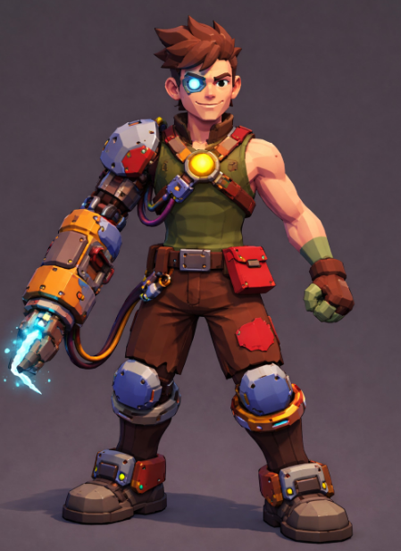
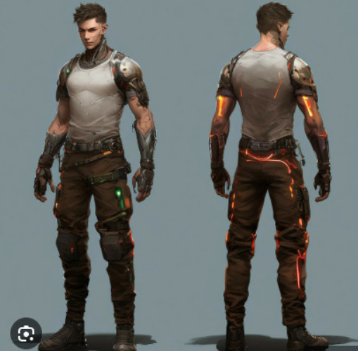

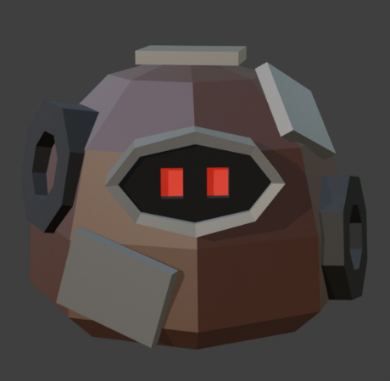
Concept art - Enemies
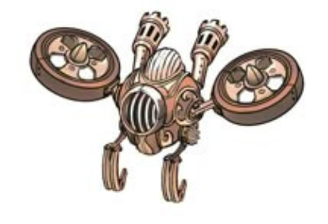
Slime enemy

Aerial enemy

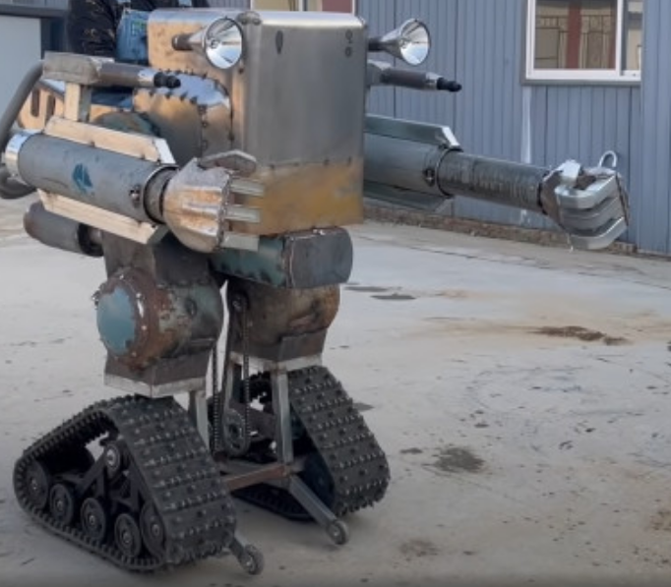
Humanoid enemy

More details here https://miro.com/app/board/uXjVGwZChAQ=/

Technical document
Link to the technical document here TECHNICAL DOCUMENT

